Liturgy For Worship at Brighton Heights Lutheran Church

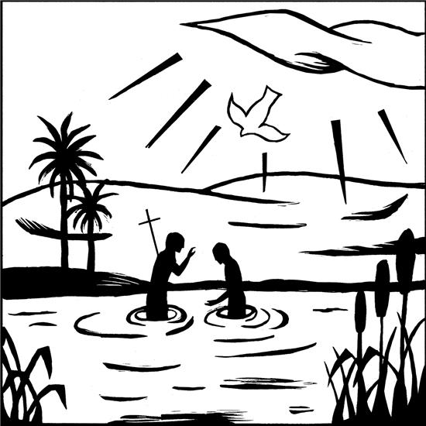
BRIGHTON HEIGHTS LUTHERAN CHURCH
3830 California Ave.
Pittsburgh, PA 15212
(412) 761-8545

www.brightonheightslutheranchurch.org
PRAISE SONGS

WELCOME AND GATHERING
P: We gather in the name of the Father, Son, and Holy Spirit

ANNOUNCEMENTS

CONFESSION AND FORGIVENESS
P: God of all mercy and consolation, come to the help of your people, turning us from our sin to live for you alone. Give us the power of your Holy Spirit that we may confess our sin, receive your forgiveness, and grow into the fullness of Jesus Christ, our Savior and Lord.
C: Amen.

P: Let us confess our sin in the presence of God and of one another.

The assembly kneels or stands. Silence is kept for reflection.

P: Most merciful God,
C: We confess that we are captive to sin and cannot free ourselves. We have sinned against you in thought, word, and deed, by what we have done and by what we have left undone. We have not loved you with our whole heart; we have not loved our neighbors as ourselves. For the sake of your Son, Jesus Christ, have mercy on us. Forgive us, renew us, and lead us, so that we may delight in your will and walk in your ways, to the glory of your holy name. Amen.

P: In the mercy of almighty God, Jesus Christ was given to die for us, and for his sake God forgives us all our sins. As a called and ordained minister of the church of Christ, and by his authority, I therefore declare to you the entire forgiveness of all your sins, in the name of the Father, and of the ☩ Son, and of the Holy Spirit.
C: Amen.

GATHERING SONG

GREETING
P: The grace of our Lord Jesus Christ, the love of God, and the communion of the Holy Spirit be with you all.
C: And also with you.

PRAYER OF THE DAY

WORD
First Reading

Psalm

Second Reading

CHILDREN’S SERMON

SERMON

Questions about the Sermon, texts, etc.
We invite any questions that are generated from any of the readings or from the sermon. Paper to write notes on the sermon can be found in the pews or use the sermon notes section on the app.

HYMN OF THE DAY:

CREED (Page 105)
C: I believe in God, the Father almighty,
creator of heaven and earth.
I believe in Jesus Christ, God’s only Son, our Lord,
who was conceived by the Holy Spirit,
born of the virgin Mary,
suffered under Pontius Pilate,
was crucified, died, and was buried;
he descended to the dead.*
On the third day he rose again;
he ascended into heaven,
he is seated at the right hand of the Father,
and he will come to judge the living and the dead.
I believe in the Holy Spirit,
the holy catholic church,
the communion of saints,
the forgiveness of sins,
the resurrection of the body,
and the life everlasting. Amen.
*Or, “he descended into hell,” another translation of this text in widespread use.

PEACE
P: The peace of Christ be with you always.
C: And also with you.

The people may greet one another with a sign of Christ’s peace, and may say, “Peace be with you,” or similar words.
The assembly is seated.
OFFERING

SANCTUARY
Lord, prepare me to be a sanctuary, pure and holy, tried and
true,
And with thanksgiving, I’ll be a living sanctuary for you.

During this time, the table is set. Feel free to come forward from the Assembly to the Alter Rail if you are in need of extra prayer.

After the offering is gathered, the assembly stands and gifts are brought forward.

Lord, prepare me to be a testimony, pure and holy, tried and true,
And with thanksgiving, I’ll be a living a testimony for you.

Lord, prepare me to be a missionary, pure and holy, tried and true,
And with thanksgiving, I’ll be a living a missionary for you.

OFFERING PRAYER

GREAT THANKSGIVING
DIALOGUE
P: The Lord be with you. C: And also with you.
P: Lift up your hearts. C: We lift them to the Lord.
P: Let us give thanks to the Lord our God. C: It is right to give our thanks and praise.

In Christ Alone (#23) Please pause between verses 2 and 3 for the consecration.

A: In Christ alone my hope is found
He is my light, my strength, my song
This cornerstone, this solid ground
Firm through the fiercest drought and storm
What heights of love, what depths of peace
When fears are stilled, when strivings cease
My comforter, my all in all
Here in the love of Christ I stand

A: In Christ alone who took on flesh
Fullness of God in helpless babe
This gift of love and righteousness
Scorned by the ones He came to save
Till on that cross as Jesus died
The wrath of God was satisfied
For every sin on Him was laid
Here in the death of Christ I live

P: In the night in which he was betrayed,
our Lord Jesus took bread, and gave thanks;
broke it, and gave it to his disciples, saying:
Take and eat; this is my body, given for you.
Do this for the remembrance of me.

A: There in the ground His body lay
Light of the world by darkness slain
Then bursting forth in glorious day
Up from the grave He rose again
And as He stands in victory
Sin’s curse has lost its grip on me
For I am His and He is mine
Bought with the precious blood of Christ

P: Again, after supper, he took the cup, gave thanks,
and gave it for all to drink, saying:
This cup is the new covenant in my blood,
shed for you and for all people for the forgiveness of sin.
Do this for the remembrance of me.

A: No guilt in life, no fear in death
This is the power of Christ in me
From life’s first cry to final breath
Jesus commands my destiny
No power of hell, no scheme of man
Can ever pluck me from His hand
Till He returns or calls me home
Here in the power of Christ I’ll stand

LORD’S PRAYER (Page 112)
P: In the power of Christ we stand and pray as Jesus taught us.
C: Our Father, who art in heaven, hallowed be thy name,
thy kingdom come, thy will be done,
on earth as it is in heaven.
Give us this day our daily bread;
and forgive us our trespasses,
as we forgive those who trespass against us;
and lead us not into temptation, but deliver us from evil.
For thine is the kingdom, and the power, and the glory,
forever and ever. Amen.

INVITATION TO COMMUNION

COMMUNION

COMMUNION SONG

POST COMMUNION BLESSING

PRAYERs AFTER COMMUNION

BLESSING

SENDING SONG

DISMISSAL

